Model | Description | Quantity | Photo
CUBE 500 | LED LAMP INTEGRATED DRIVER  POWER SUPPLY 220 VOLTS | 400 | 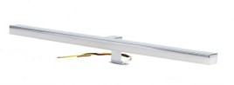
VULCANO 450 | LED LAMP INTEGRATED DRIVER  POWER SUPPLY 220 VOLTS | 300 | 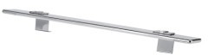
VULCANO 600 | LED LAMP INTEGRATED DRIVER  POWER SUPPLY 220 VOLTS | 300 | 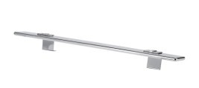
PRISCA | UPLIGHTERS CHROMED ALUMINIUM – OPAL GLASS WITH DIRECT CONNECTION  ON MIRROR E14 | 1000 | 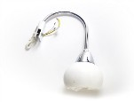
OTHB SNAKE | BRONZE LAMP WITH ELECTRIC CONNECTION E14 | 500
sv lamp | Chromed aluminium Lamp Modern design with frame Connection and integrated driver  Connectable to network | 700
eco led lamp | Uplighters with connection to Frame and mirror  3 watt power with integrated Driver to product | 8000 | 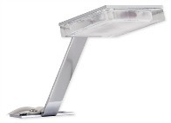
allu 200 led | Aluminium Lamp length 200 mm Integrated driver | 2000 | 